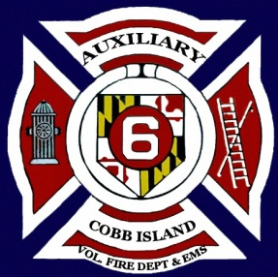
NOW ACCEPTING DONATIONS FOR OUR AUCTION
INCLUDING NEW, ANTIQUES OR GENTLY USED ITEMS.
CALL 301-259-4375 or 301-259-2730.
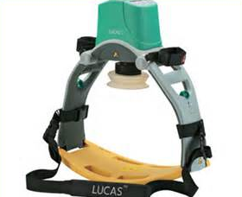
This auction is being held to raise funds for a
“LUCAS Chest Compression System”
for our ambulance. A Life Saving Device!
Saturday, May 16, 2015

Buffet Dinner and Silent Auction
Starts at 6:00 p.m.
Tickets on Sale Now!
Sold in advance $16 per person.
Tickets at door $20 per person.
Contact:
301-259-4375

Or

301-259-2730
Cobb Island Vol. Fire Dept.
17069 Cobb Island Road
Cobb Island, MD 20625
(301) 259-4258

Silent Auction Cutione!

&Dinner!

